Exercises to work out and turn in:
Grading Guidelines (See Appendix):
In general, a right answer will get full credit when:

- It is right (worth 25%)
- It is right AND neatly presented making it easy and pleasant to read. (worth an extra 15%)
- There is an obvious and clear link between 1) the information provided in the exercise and in class and 2) the final answer. A clear link is built by properly writing, justifying, and documenting an answer (worth an extra 60%).
- Calculation mistakes will be minimally penalized (2 to 5% of full credit) while errors on units will be more heavily penalized.

Late Submission : as specified in the syllabus. Day counting starts one minute after the deadline.
Check Your Submission: after submitting, download your submission to check whether it is the right version and it is complete. A wrong version will get at least a 25 points penalty that cannot be claimed back by the Leniency Policy for Borderline Incidents. So, check your submissions.

You are welcome/encouraged to discuss exercises with other groups or the instructor. But, ultimately, personal writing is expected.
- USE THIS EDITABLE FILE AS THE STARTING DOCUMENT YOU WILL TURN IN. KEEP IN THE QUESTIONS AND INSERT YOUR ANSWERS RIGHT AFTER THE QUESTIONS/PROMPTS. DO NOT DELETE ANYTHING.
- IF USING HAND WRITING (STRONGLY DISCOURAGED), REWRITE THE QUESTIONS.
- FAILING TO FOLLOW TURN IN DIRECTIONS /GUIDELINES WILL COST A 30% PENALTY.

Objectives of this assignment:
- to work on a Unix based system
- to explore the impact of the memory accesses pattern on the performance

What you need to do:
- to work on a Unix based system
- Review a few Unix commands
- Analyze the time complexity of two algorithms that perform the same number of instructions
- Explore the impact of the memory accesses pattern on the execution time

Important:
- One submission per team. You must complete all tasks on an Engineering Unix Tux machine, otherwise a 0 will be assigned.
- Writing and presentation of your report are considered to grade your hands-on lab. Your conclusions must be supported by the data/measurements you collect. Your conclusions must be correct.
- Questions about this lab must be posted on Piazza if you need timely answers.
- Work ahead. Do not wait until the last minute.

(Reminder) In order to save space, for this assignment and future ones, clip out the screenshots to contain only the relevant information (the date, the Tux machine you are using for the question, the Auburn username, and material related to the question/task). A 25 points penalty will be applied when any required information is missing. Make sure that the screenshots are easily readable.

Task 1: Basic Unix Commands (20 points)

(Well written short answers are acceptable for this assignment)
The objective of this exercise is to get familiar with basic frequently used commands.

In order to save space, for this assignment and future ones, clip out the screenshots to contain only the relevant information. Make sure that the screenshots are easily readable.

1) (4 points) The shell allows redirection of the output. By default, the result of your commands is displayed by default on the terminal. You can redirect the "displaying" onto a file. For example, execute these commands in your nnnn directory you created for this course (nnnn is your course #):
- ls
- ls > dump
- cat dump
Take a screenshot and insert it here. 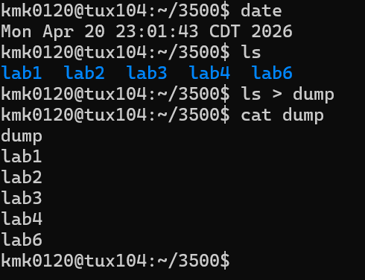

2) (4 points) What does the command wc do?
Execute these commands under the same directory where the file dump is:
- wc dump
- wc -l dump
Take a screenshot and insert it here. 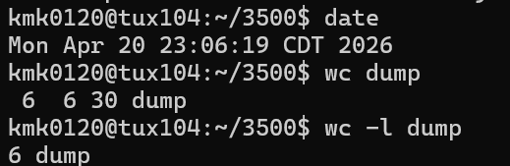
The wc command displays the word count, line count, and byte count for files

3) (4 points) Download the files poem1.tex and poem2.tex. These are slightly different translations of Rimbaud's poem "Le Dormeur Du Val". How do they differ? Here is a command you could use:
- cmp poem1.tex poem2.tex
- cmp -b poem1.tex poem2.tex
Take a screenshot and insert it here.
Poem 1 says “in his right side” on the last line last four words, while poem 2 says “on his right side” as shown in the screenshot since it says line 17 is 151 I and 157 o showing this difference.
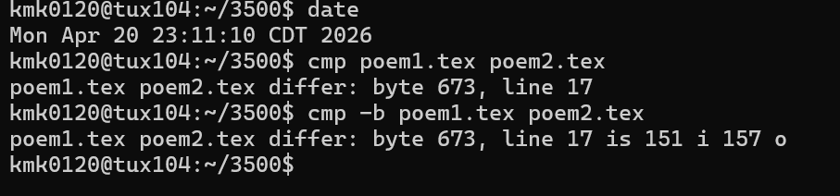

4) (4 points) What does the command grep do?
Execute these commands under the same directory where the files poem1.tex and poem2.tex are.
- grep his poem1.tex // no space around "."
- echo po*.tex // no space around "."
- grep his po*.tex // no space around "."
Take a screenshot and insert it here. 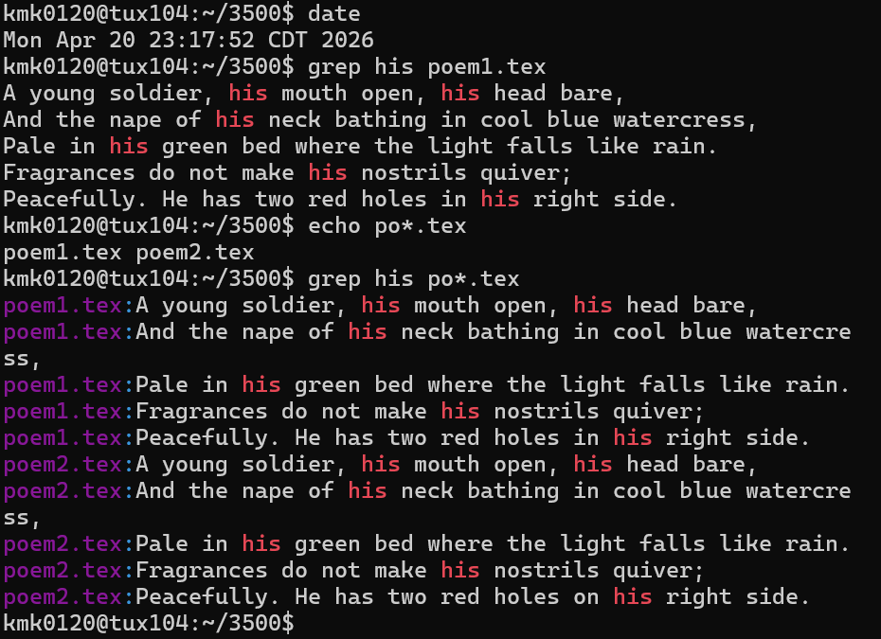
The grep command is used to search files for a specific text

5) (4 points) The ampersand character & allows to use the shell (command prompt) while a command or a program is being executed. Execute these commands to see the effect of & (emacs is a popular editor):
- emacs&
- ps
-emacs&
- ps
Kill the two emacs processes
Take a screenshot (must show starting from the first command emacs&) and insert it here.
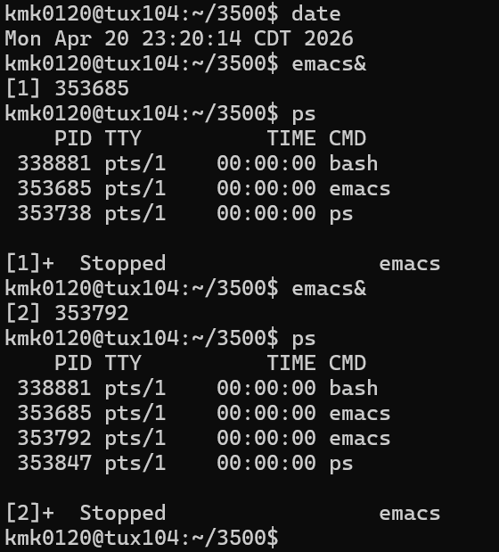

Task 2 (80 points)

The objective of this task is to explore the impact of the pattern of the memory accesses on the execution time of a program. In order to complete this exploration, you must measure the execution time of two algorithms that execute the same job by performing exactly the same number of instructions/operations. After measuring, you must draw conclusions and explain potential differences between the execution time of the two algorithms. You must work these hands-on laboratory exercise on a Tux machine.

Exercise: For this exercise, you must work with the lab6.c program. This program will allow you to collect data.
1) (5 points) Consider the following algorithm:
InitializeMatrix0(M,n) // Version 0
inputs: Matrix $M$ of characters, $n$, the dimension of the nxn M matrix
output: none. Each element of Matrix M is initialized with '0'
for i = 1 to n
for j = 1 to n
Matrix[i][j] = '0';

What is the time complexity of the above algorithm (Version 0) when you count the assignments "Matrix[i][j]='0';". How many of these assignments will be executed? Express this number as a function of $n$.
Answer here ... (Brief justification is expected. I trust that you know now how to analyze such algorithm)
The outer loop (for j = 1 to n) starts with j=1 and executes the loop n times, incrementing j to j=n. Thus, the outer loop is executed n times. Similarly, the inner loop (for i = 1 to n) starts with i=1 and executes the loop n times, incrementing i to i=n. Thus, the inner loop is executed n times. Inside the inner loop is the assignment statement “Matrix[i][j] = '0';”. Since the loops are nested, the outer loop executes n times, and each time it executes, the inner loop executes n times. The assignment statement has a time complexity of O(1). Since the algorithm is a nested loop, the time complexity of the algorithm is the time complexity of the statement inside the inner loop multiplied by the number of times the inner loop executes, multiplied by the number of times the outer loop executes. Thus, the time complexity of the algorithm is $1×n×n =n^{2}$ So the big O time complexity is O($n^{2})$. The time complexity is O($n^{2})$ since the assignment statement has a complexity of O(1), which is executed n times by the inner loop, which is executed n times by the outer loop. Also, because of this logic, the assignment statement is executed n times by the inner loop, which is executed n times by the outer loop. So, the assignment statement is executed n times for every n times the outer loop executes. That means the assignment statement executes $n^{2}$ times.
2) (5 points) Consider the following algorithm:
InitializeMatrix1(M,n) // Version 1
inputs: Matrix $M$ of characters, $n$, the dimension of the nxn M matrix
output: none. Each element of Matrix M is initialized with '0'
for j = 1 to n
for i = 1 to n
Matrix[i][j] = '0';

What is the time complexity of the above algorithm (Version 1) when you count the assignments " Matrix[i][j]='0';". How many of these assignments will be executed? Express this number as a function of $n$.
Answer here ... (Brief justification is expected. I trust that you know now how to analyze such algorithm). The outer loop (for j = 1 to n) starts with j=1 and executes the loop n times, incrementing j to j=n. Thus, the outer loop is executed n times. Similarly, the inner loop (for i = 1 to n) starts with i=1 and executes the loop n times, incrementing i to i=n. Thus, the inner loop is executed n times. Inside the inner loop is the assignment statement “Matrix[i][j]='0';”, which has a time complexity of O(1). Since the algorithm is a nested loop, the complexity of the algorithm is the complexity of the singular statement in the inner loop multiplied by the number of times the inner loop executes, multiplied by the number of times the outer loop executes. So the time complexity is of the algorithm is $1×n×n =n^{2}$ So the big O time complexity is O($n^{2})$. The number of assignments is based on the number of times the statement “Matrix[i][j]='0';” executes. “Matrix[i][j]='0';” executes once every time the inner loop executes, which is n times. However, since the outer loop executes the inner loop n times, the assignment statement executes $n×n =n^{2}$since the inner loop executes it n times for every n times the outer loop executes. So “Matrix[i][j]='0';” executes $n^{2}$ times, meaning there are $n^{2}$ assignments made.

3) (10 points) Check within the source program lab6.c whether the C code implements "faithfully" the pseudocode for both version to initialize the matrix (Examine the methods InitializeMatrix0 and InitializeMatrix1). Compare the two algorithms: do they perform the same job? do they execute the same number of operations? what is the key difference between the two algorithms? If these two algorithms execute under the exactly same conditions (same hardware, OS, load...), should them perform similarly (same execution time)? Answer/Justify/Explain
Answer here ...
“void InitializeMatrix0(Quantity Dimension){
int i,j;
for (i = 0; i < Dimension; i++){
for (j = 0; j < Dimension; j++){
Matrix[i][j] = '0';
}
}
}
“ This code implements the pseudocode of version 0 faithfully. This is because in the pseudocode the outer loop loops from i=1 to i=n which is all of the positions i could be from the first one, 1, to the highest one n. Each time the outer loop executes the inner loop. The inner loops from j=1 to j=n, which is all of the positions j could be in the matrix from the first one, 1, to the highest one, n. Inside the inner loop is the assignment statement. The same logic is used in the code because the outer loop “for (i = 0; i < Dimension; i++){“ starts at i=0, which is the first position an index can be in code, and increments everytime it loops till i < Dimension is false. This loops over all the positions i can be in the matrix incrementing i each time since it says “i++” For possible positions of i = to Dimension. Since index starts at 0, the first position for i in the matrix is 0 and the highest is Dimension – 1. That is why as i increments the loop stops once it is not < Dimension since it would not be a possible position of i. The inner loop in the code is also the same logic as the pseudocode since it also goes over all positions j can be by starting at the beginning index j=0 and stopping once j < Dimension is false since to have the index start as 0 and the number of positions of j = to Dimension the highest a position can be is Dimension – 1. Therefore the inner loop also goes over all possible positions of j. Inside the inner loop is the same assignment statement Matrix[i][j] = '0';. Therefore the codes logic is the same as the pseudocode.
“void InitializeMatrix1(Quantity Dimension){
int i,j;
for (j = 0; j < Dimension; j++){
for (i = 0; i < Dimension; i++){
Matrix[i][j] = '0';
}
}
}
“ implements "faithfully" the pseudocode for version 1. In the pseudocode the outer loop goes over all the possible positions of j from the first one j=1 to the highest one j=n and then the inner loop goes over all positions of i from first one i=1 to the highest i=n and the inner loop contains an assignment statement to assign the position (i,j) in the matrix to 0. The code follows this logic since the outer loop goes over all the positions of j by starting at the first possible index, 0 which is the first position j could be and the incrementing j as it loops till it’s the highest position it could be Dimension-1 by stopping when j increments and j < dimension is no longer true. The inner loop also goes over over all the positions of i by starting at the first possible index, 0 which is the first position i could be and incrementing i as it loops till it’s the highest position it could be Dimension-1 by stopping when i increments and i < dimension is no longer true. And inside the inner loop is Matrix[i][j] = '0'; which assigns the position (i,j) in the matrix to 0. Thus the code and the pseudocode have the same logic.
Yes the algorithms do the same job, they both go through all the elements in the matrix and sets the element to 0 for every position of i and j. They create the same matrix in the end since they both set all the elements in the matrix = to 0. The key difference is version 0 uses i in the outer loop and j in the inner loop, going through all possible positions j for each position i. In contrast, version 1 uses j in the outer loop and i in the inner loop, going through all possible positions i for each position j. Since they both follow the logic of the pseudocode, theoretically, they should both have a complexity of O($n^{2})$ same as the pseudocode. So, they should perform similarly.

4) (5 points) Download the program lab6.c. Compile it by typing cc -o lab6 lab6.c. Execute the program lab6 by typing: ./lab6 maxdimension step Version where maxdimension is the dimension of the largest matrix M to initialize, step is the step of the data points, and Version is the version (0/1) of the algorithm. Below is the pseudocode of lab6.c:
LaunchExperiment(M, n)
inputs: Matrix $M$ of characters,
$maxdimension$, the dimension of the largest matrix M to initialize,
step is step between data points (see pseudocode)
Version is the version of the algorithm to use
output: a file containing the execution time for a given matrix dimension. File is named file-maxdimension-step-Version0/1.csv. This file can be opened with Excel for plotting....
for dimension = step to maxdimension (increasing by step)
if Version == 0
InitializeMatrix0(M,dimension) // Version 0
else
InitializeMatrix1(M,dimension) // Version 1
write in file dimension and execution time of InitializeMatrix0/1(M,dimension)

For example, if you execute ./lab6 16384 2048 1, LaunchExperiment will initialize the matrices with dimensions 2048, 4096, 6144, 8192, 10240, 12288, 14336, and 16384, respectively. For each initialized matrix, it will collect the execution time and will write the pairs (dimension, execution time) in a file named file-16384-2048-Version1.csv (recall 16384 is maxdimension, 2048 is the step, and 1 is the version). You will find the data in such a file to build plots. This file can be opened by Excel (csv format).
For this question Execute and time ./lab6 32768 2048 0, report the time it takes to complete the execution time, take a screenshot of the execution (clip out the screenshot) and insert it here..
Hint: to time the execution, you can simply type time ./lab6 32768 2048 0
The time it took in real time was 5.698 seconds to complete execution.
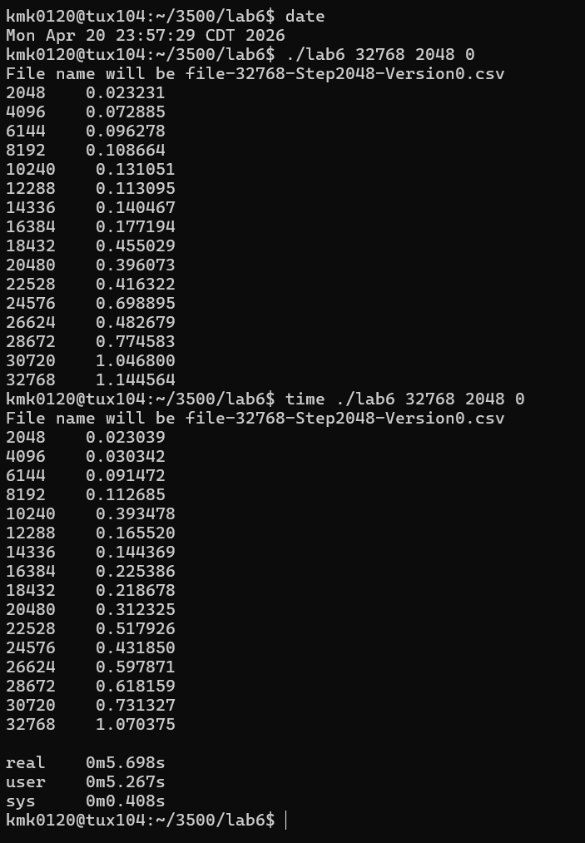

5) (5 points) Execute and time ./lab6 32768 2048 1, report the time it takes to complete the execution time, take a screenshot of the execution (clip out the screenshot) and insert it here..
Hint: to time the execution, you can simply type time ./lab6 32768 2048 1
The execution time as seen below for real time was four minutes and 32.350 seconds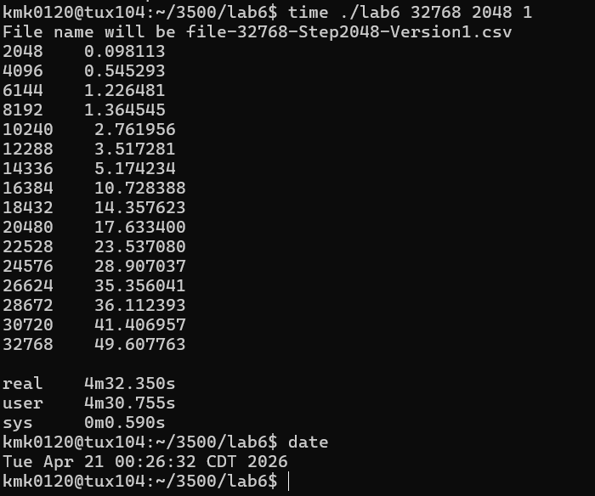

6) (30 points)
a) Execute time ./lab6 65536 4096 0 , collect and submit the file file-65536-4096-Version0.csv
b) Execute time ./lab6 65536 4096 1 and collect the file file-65536-4096-Version1.csv.
c) (15 points) Build on the same graph the plots of execution time of the two versions of the algorithms (0 and 1) versus the matrix dimension: put the matrix dimension on the x-axis and the execution time on the y-axis.
Insert here the above graph.
d) (15 points) Build the plot of $\frac{Execution Time (Version 1)}{Execution Time (Version 0)}$ as a function of matrix dimension: put matrix dimension on the x-axis and $\frac{Execution Time (Version 1)}{Execution Time (Version 0)}$ on the y-axis.
Insert here the above graph.

7) (5 points) Comment and discuss the two graphs built above. Highlight the potential differences (execution time) between Version 0 and Version 1 of the matrix initialization algorithm.
The first graph shows two lines that chart the execution time for each version based on the matrix dimensions. As the matrix dimensions get bigger, the execution time seems to increase for both versions. Execution time for version 1 grows much faster than version 0. As the matrix dimension grows, the gap in the execution time of version 0 and version 1 grows. Version 1 execution time gets significantly larger than version 0 as the matrix dimension grows. Both of the versions execution times grow quadratically as matrix dimension grows. Though the execution times don’t grow exactly at O($n^{2}$), both grow from 3x to 5x larger as the matrix dimension doubles, thus showing that they are approximately quadratic but not exactly. However, version 1 stays much larger than version 0. In the second chart, it shows the $\frac{Execution Time (Version 1)}{Execution Time (Version 0)}$ as a function of matrix dimension. In this, we can see that version 1 starts 7x larger than version 0. As the matrix dimension grows, version 1 stays between 16x and 26x larger than version 0 in the matrix dimensions tested. Version 1 starts 7x larger, showing that it takes much longer even when the matrix dimensions are smaller, and thus version 1 is a slower algorithm, no matter the matrix dimension, but it does get worse as the matrix dimension increases. Version 0 is much faster, even as the matrix dimension grows.

8) (15 points) Why? Provide the reason of the potential difference in execution times between Version 0 and Version 1 of the matrix initialization algorithm.
The key difference in the algorithms is that version 0 goes by row and assigns each element in a row, then moves to the next row. Version 1 goes by column and assigns each element in a column, then moves to the next column. Although the logic for both versions of the nested loop theoretically has a time complexity of O($n^{2}$), the way the memory is allocated changes the execution time and efficiency of the algorithms. In C, matrices are stored by row. When version 0 is used, the elements changed in the algorithm are done by row, then column. Because of this, memory is accessed in a similar order to how they are stored, elements are closer together in memory, and cache hits are more likely to happen. Version 0 allows memory to be accessed and changed contiguously. Version 1 changes the elements by column. Because of how it is stored in memory, accessing elements in version 1 requires jumps in the memory. The elements being far away from each other in memory makes execution take longer, and a cache hit is less likely.

Do not hesitate to ask questions on Piazza if you have any doubt.
Common mistake
Starting the hands-on lab at the last minute.

What to turn in?
One file
- Electronic copy of this file that includes your answers. I repeat: you must insert your answers in this file. Do not delete anything from this file. This file with your answers must be put posted separately on Canvas (not in a zipped folder).
- Electronic copy of the files file-65536-4096-Version0.csv and file-65536-4096-Version1.csv.
Good writing and presentation are expected.

In case of doubt, do not hesitate to ask questions on Piazza.

What you need to turn in:
- Electronic copy of this file (including your answers) (standalone). Submit the file as a Microsoft Word or PDF file.

- Recall that answers must be well written, documented, justified, and presented to get full credit.

- How this assignment will be graded:
- A right answer will get full credit when:
- It is right (worth 25%)
- It is right AND neatly presented making it easy and pleasant to read. (worth 15%)
- There is an obvious and clear link between 1) the information provided in the exercise and in class and 2) the final answer. A clear link is built by properly writing, justifying, and documenting an answer (worth 60%).
- Calculation mistakes will be minimally penalized (2 to 5% of full credit) while errors on units will be more heavily penalized.

- You are welcome/encouraged to discuss exercises with other students or the instructor. But, ultimately, personal writing is expected.

Appendix: Grading: What is an OBVIOUS and CLEAR LINK?
Here is an example to explain what an obvious and clear link is and how we grade your work.
Consider the following problem:
"(100 points) John travels from Auburn to Atlanta in his car at a speed of 50 mph. Leaving at 8am, at what time will John reach Atlanta".
Here are the answers of three students and their scores:
Student 1 answers: "10am". Student 1 will get 25 points.
Student 2 answers : "John will reach Atlanta at 10am". Student 2 will get 25+15 = 40 points
Student 3 answers: "The time t to travel a distance d at speed v is equal to d/v = d/50mph. The problem does not provide the distance d from Auburn to Atlanta. Based on Google, the distance from Auburn to Atlanta is approximately 100 miles (document is here). Therefore, the time t = 100 miles/50mph = 2 hours. Since John left at 8am, he will then reach Atlanta at 8am + 2 hours = 10 am".
Student 3 will get 25 + 15 + 60 = 100 points
Do you see the direct link going from the data provided in the question to the final answer, using general knowledge/formula and documents?.... Can you now solve the following problem and get 100 points?
"(100 points) Alice travels from Auburn to Atlanta in her car at a speed of 50 mph. Leaving at 8am, at what time will Alice reach Atlanta assuming that she had a flat tire that delayed her 30 minutes".

Screenshot: Required Information
In order to save space, for this assignment and all FUTURE ones, clip out the screenshots to contain only the relevant information. When applicable, ALL screenshots must show the date, the Tux machine you are using for the exercise and the Auburn username of one of the team mates. Make sure that the screenshots are easily readable. Below is template screenshot:

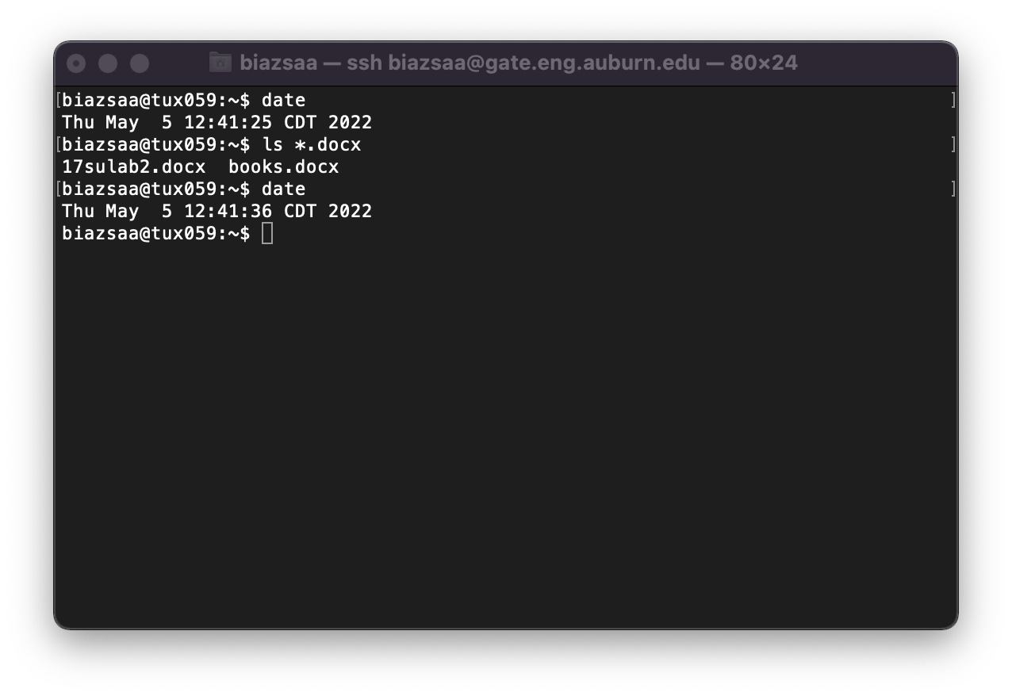

See on the appendix what an obvious and clear link is.
See Appendix About the REquired Information On All Screenshots

